Mathematics Stack Exchange

🎓 Definition
# Source: ScreenShots Source: Provided by: [Persons Table -> ID Column: 1, Name_En Column: Motasem Essam] -> Tool: [Lightshot Program] -> From [Site: https://stackexchange.com/] on [11/13/2025]
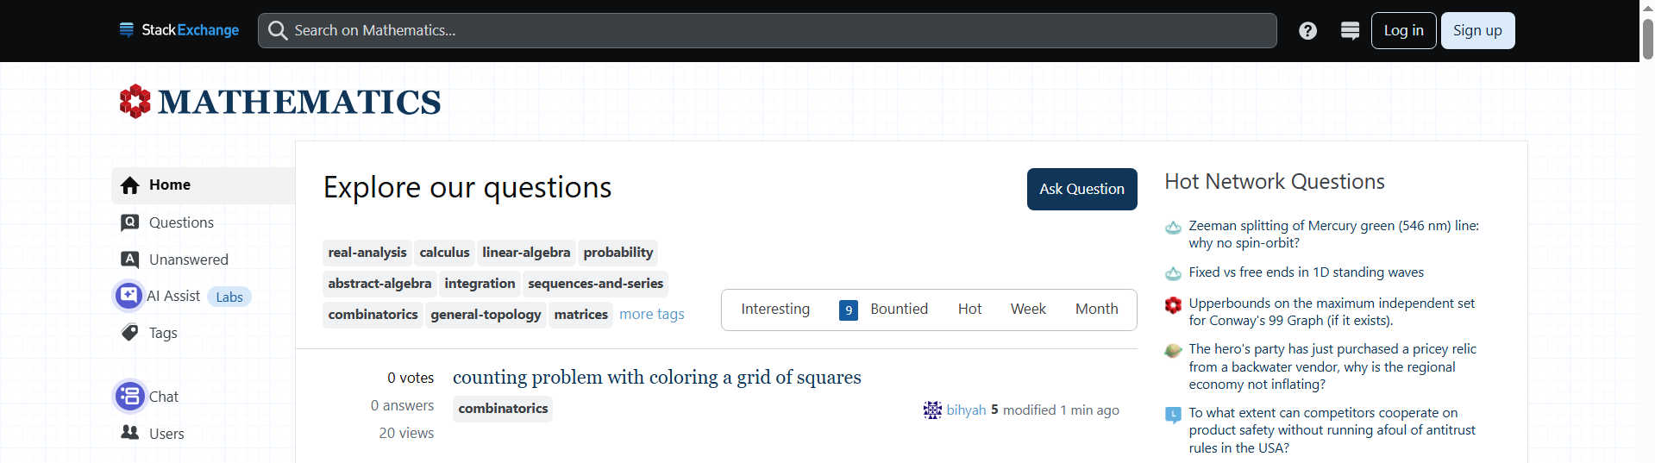
# Source: AI Source: Provided by: [Data Path: Persons Table -> ID Column: 1, Name_En Column: Motasem Essam] -> From: [ChatGPT] on [11/13/2025]
Mathematics Stack Exchange (Math SE) — https://math.stackexchange.com/ — is a specialized Q&A site within the Stack Exchange network, focused exclusively on mathematics. Here’s a detailed breakdown:

📌 Overview
# Source: AI Source: Provided by: [Data Path: Persons Table -> ID Column: 1, Name_En Column: Motasem Essam] -> From: [ChatGPT] on [11/13/2025]
- Part of the Stack Exchange network, Math SE is dedicated to all levels of mathematics:
  - High school, undergraduate, and graduate-level questions
  - Topics include algebra, calculus, geometry, number theory, combinatorics, probability, statistics, and more
- Users ask mathematical questions, and other community members provide solutions, explanations, or hints.

⚡ Key Features
# Source: AI Source: Provided by: [Data Path: Persons Table -> ID Column: 1, Name_En Column: Motasem Essam] -> From: [ChatGPT] on [11/13/2025]
- Voting & Reputation: High-quality answers get upvoted, which increases the poster’s reputation and privileges.
- Tagging: Questions are organized with tags like linear-algebra, calculus, probability, etc., making it easy to find related topics.
- Peer-reviewed Answers: Community moderation ensures answers are accurate and well-explained.
- Free Access: Reading questions/answers is free; account creation allows posting and interacting.

✅ Purpose
# Source: AI Source: Provided by: [Data Path: Persons Table -> ID Column: 1, Name_En Column: Motasem Essam] -> From: [ChatGPT] on [11/13/2025]
- To provide a reliable, expert-driven resource for learning and solving mathematical problems.
- Encourages clear, detailed, and rigorous explanations, unlike casual discussion forums.

🛡️ Safety & Legality
# Source: AI Source: Provided by: [Data Path: Persons Table -> ID Column: 1, Name_En Column: Motasem Essam] -> From: [ChatGPT] on [11/13/2025]
- Fully legal and safe.
- No software downloads or pirated content.
- Focused solely on knowledge sharing and problem solving.

📌 Summary
# Source: AI Source: Provided by: [Data Path: Persons Table -> ID Column: 1, Name_En Column: Motasem Essam] -> From: [ChatGPT] on [11/13/2025]
Mathematics Stack Exchange is a trusted educational platform for asking and answering mathematics questions of all levels. It’s part of the broader Stack Exchange network but specializes exclusively in math.

